# Question no 1:

#include<iostream>

using namespace std;

int large(int a, int b, int c)

{

if ((a > b) && (a > c))

{

return a;

}

else if ((b > a) && (b > c))

{

return b;

}

else

{

return c;

}

}

int main()

{

cout << "execution starts from main" << endl;

int x, y, z;

cout << "enter three numbers:" << endl;

cin >> x >> y >> z;

int no;

no = large(x, y, z);

cout << "largest number is: " << no << endl;

system("pause");

return 0;

}

Result: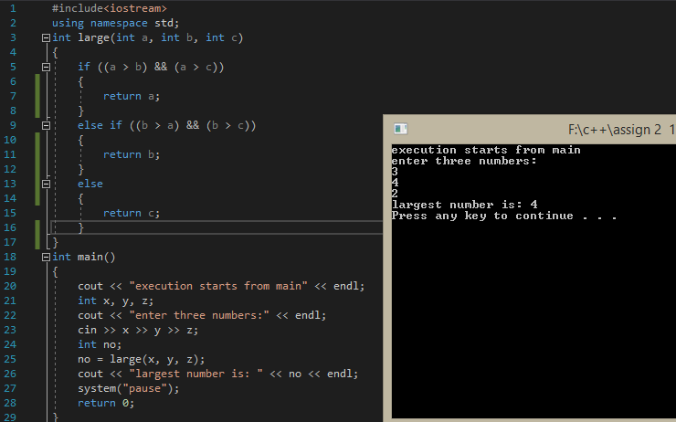

# Question no 2:

#include<iostream>

using namespace std;

int number()

{

int x;

cout << "enter a no" << endl;

cin >> x;

if (x % 2 == 0)

{

return 0;

}

else

{

return 1;

}

}

int main()

{

int a;

a = number();

cout << "return number is: " << a << endl;

system("pause");

return 0;

}

Result:

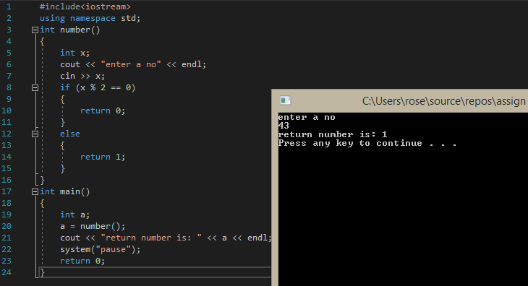

# Question no 3:

#include<iostream>

using namespace std;

int input()

{

int a;

cout << "Enter basic salary of employee:" << endl;

cin >> a;

return a;

}

int calculate(int pay)

{

int rent, allowance;

if (pay < 50000)

{

rent = (pay * 10) / 100;

allowance = (pay * 90) / 100;

}

else

{

rent = (pay * 20) / 100;

allowance = (pay * 95) / 100;

}

int salary = rent + allowance + pay;

return salary;

}

void print(int s)

{

cout << "Gross salary of employee is:" << s << endl;

}

int main()

{

int x, y;

x = input();

y = calculate(x);

print(y);

system("pause");

return 0;

}

Result:

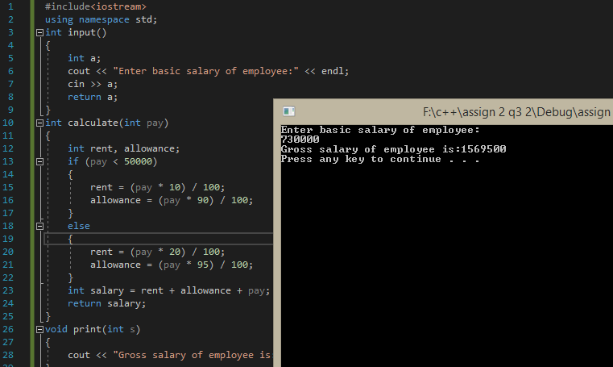

# Question no 4:

#include<iostream>

using namespace std;

void character(char c)

{

if ((c == 'T') || (c == 't'))

{

cout << "\'Tahir\'" << endl;

}

else if ((c == 'H') || (c == 'h'))

{

cout << "\'Haider\'" << endl;

}

else if ((c == 'R') || (c == 'r'))

{

cout << "\'RIji\'" << endl;

}

else if ((c == 'U') || (c == 'u'))

{

cout << "\'Uzma\'" << endl;

}

else

{

cout <<"\'"<< c <<"\'"<< endl;

}

}

int main()

{

cout << "execution starts from main" << endl;

char ch;

cout << "enter a character for a name" << endl;

cin >> ch;

character(ch);

system("pause");

return 0;

}

Result:

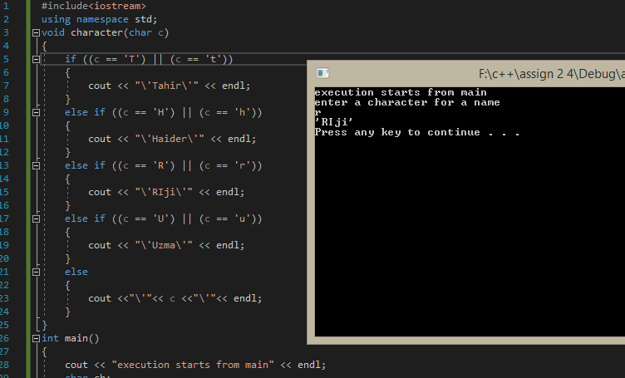

# Question no 5:

#include<iostream>

using namespace std;

int input()

{

int x;

cout << "How many snacks would you like?" << endl;

cin >> x;

return x;

}

void check(int p)

{

if (p <= 0)

{

cout << "enter a valid number" << endl;

}

}

float calculate(int x, int c)

{

float d, dis;

if ((x >= 5) && (x <= 10))

{

d = (c * 10) / 100;

dis = c - d;

return dis;

}

else if ((x >= 11) && (x <= 20))

{

d = (c * 15) / 100;

dis = c - d;

return dis;

}

else if ((x >= 21) && (x <= 30))

{

d = (c * 20) / 100;

dis = c - d;

return dis;

}

else if (x >= 31)

{

d = (c * 25) / 100;

dis = c - d;

return dis;

}

else

{

return c;

}

}

void print(int b)

{

cout << "amount to pay after discount is $" << b << endl;

}

int main()

{

int a, cost;

a = input();

cout << "cost per snacks is $12 ";

cost = 12 * a;

cout << "and the total cost is $" << cost << endl;

check(a);

if (a > 0)

{

float y;

y=calculate(a, cost);

print(y);

}

else

{

check(a);

}

system("pause");

return 0;

}

Result:

